|  |  |
| --- | --- |
| **[Project] – External Document** |  |
| COMP6681001  Web Programming |
| Odd Semester Year 2022/2023 |

* Project Title

Movie List

* Introduction

Movie List is a famous movie website made by a famous computer science student. In that website, people can find information about the Famous Movie’s list. This website enables the users to add the movie to their watchlist.

Prerequisite:

* Run “composer install”
* Run “npm run watch” for tailwind

Then, you can “php artisan serve” as usual.

* Report / Documentation

1. Login Page

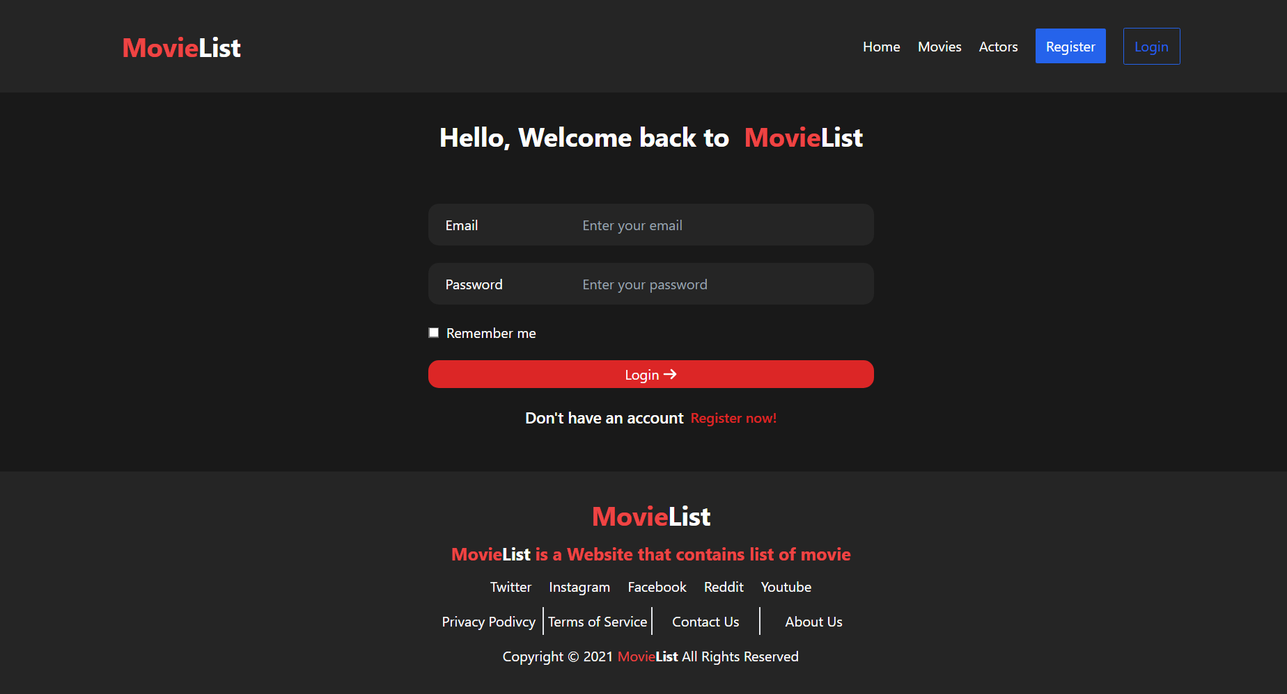

1. Register Page

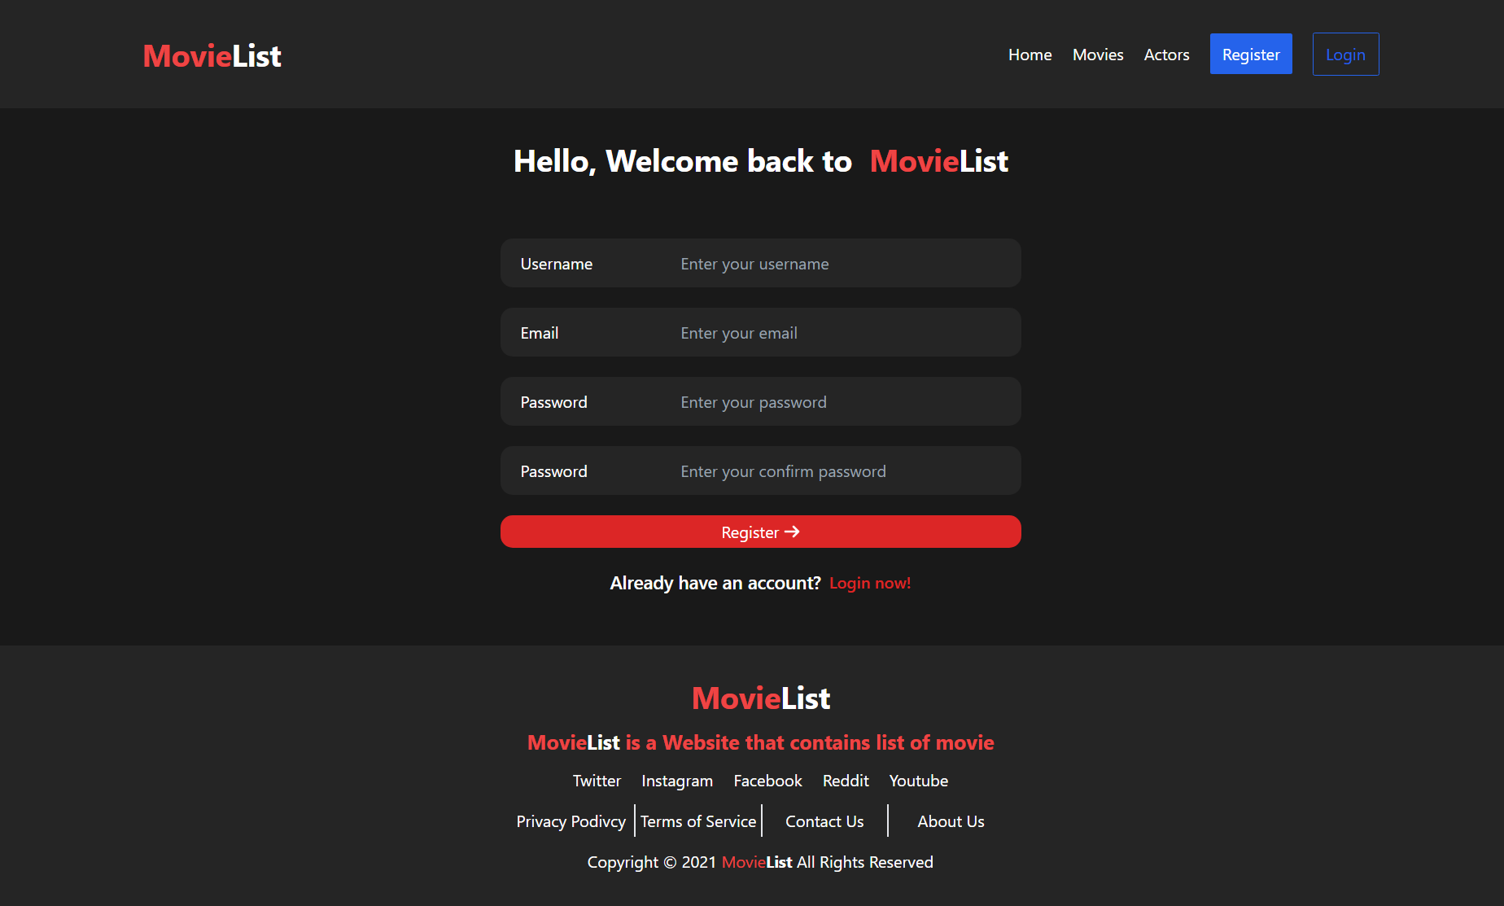

1. Home Page
   1. Guest

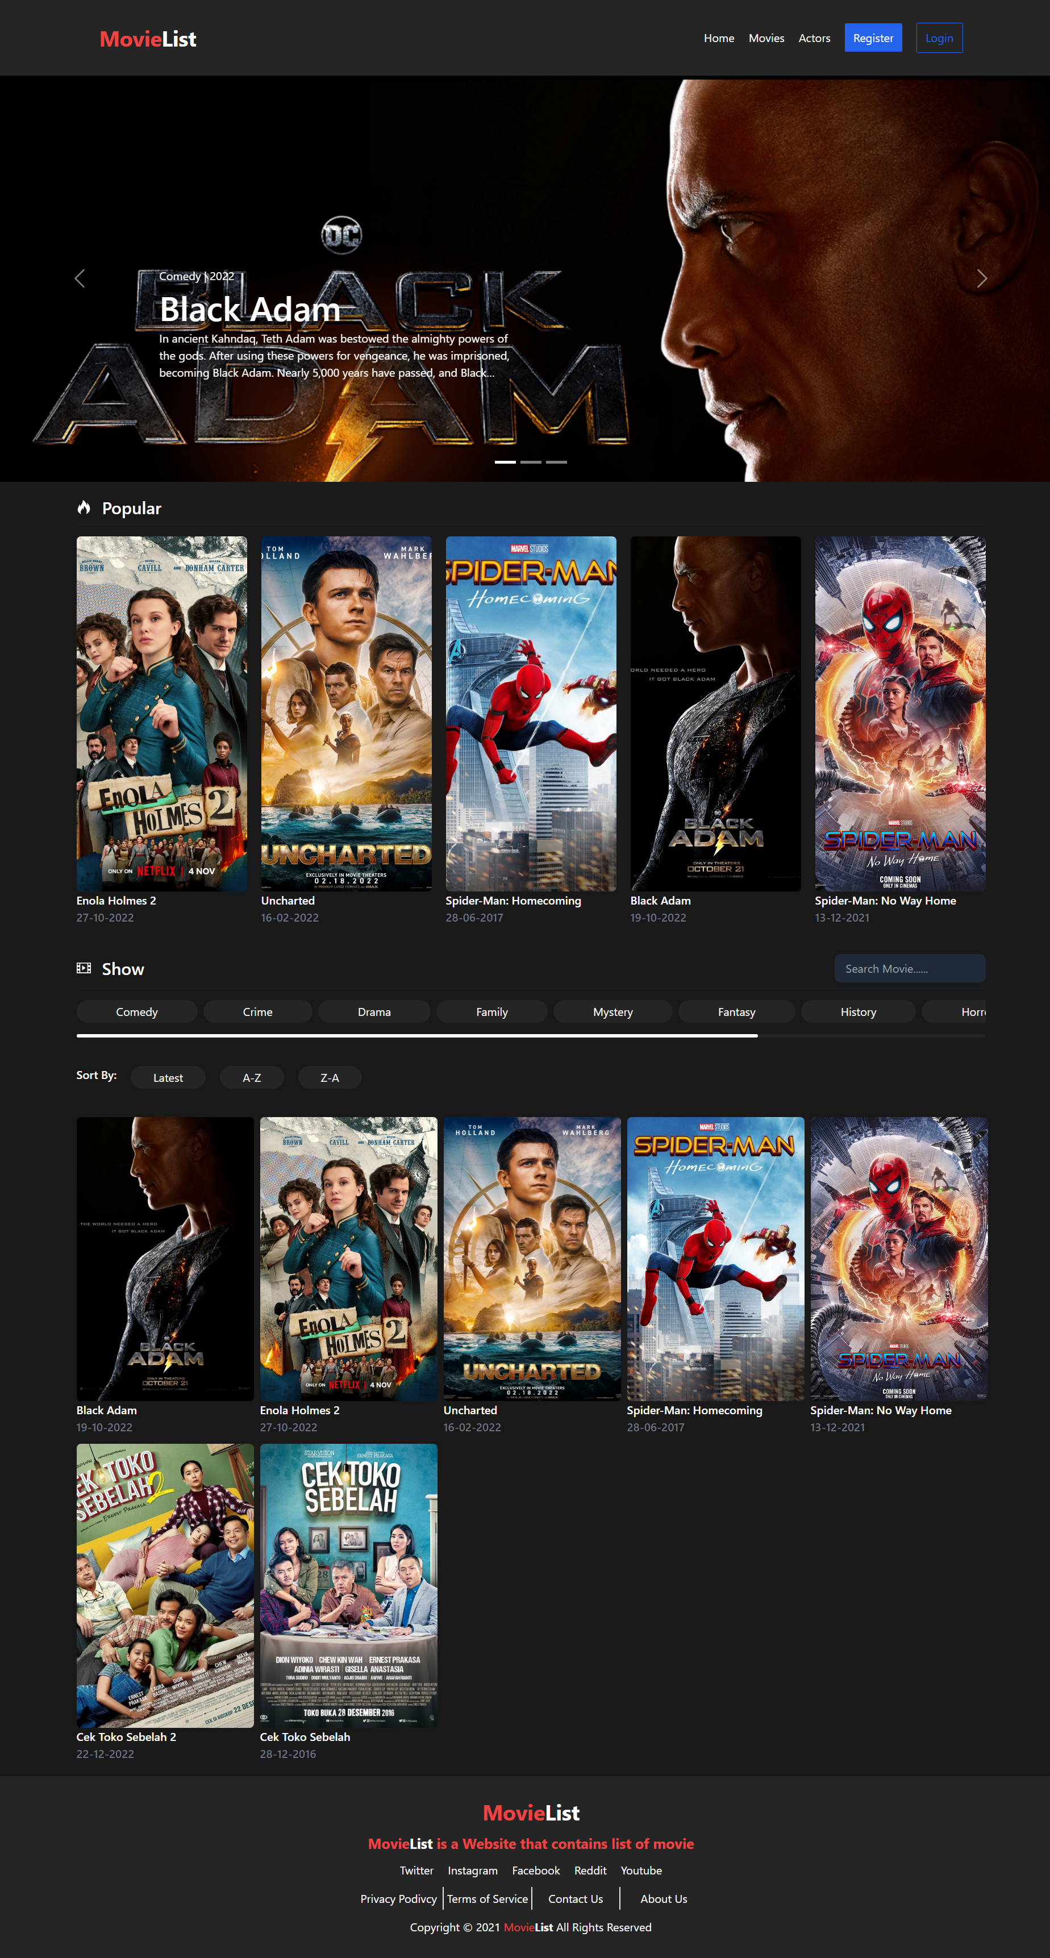

* 1. User

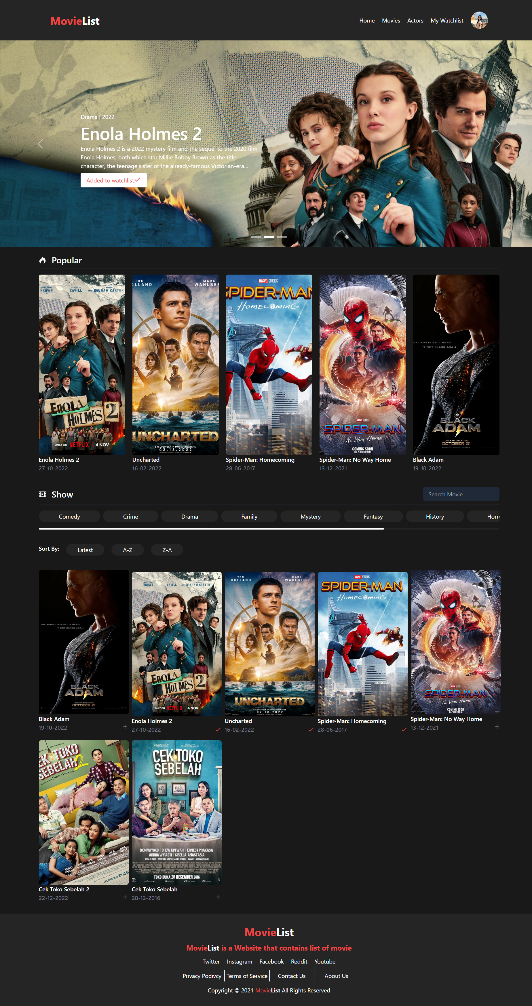

* 1. Admin

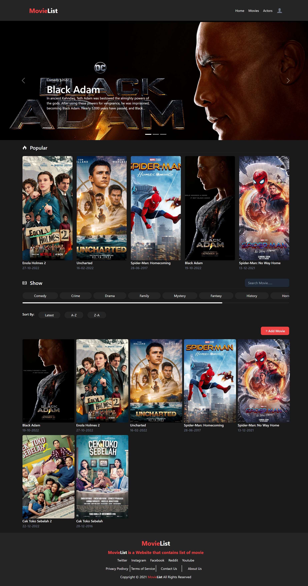

1. Create Movie Page

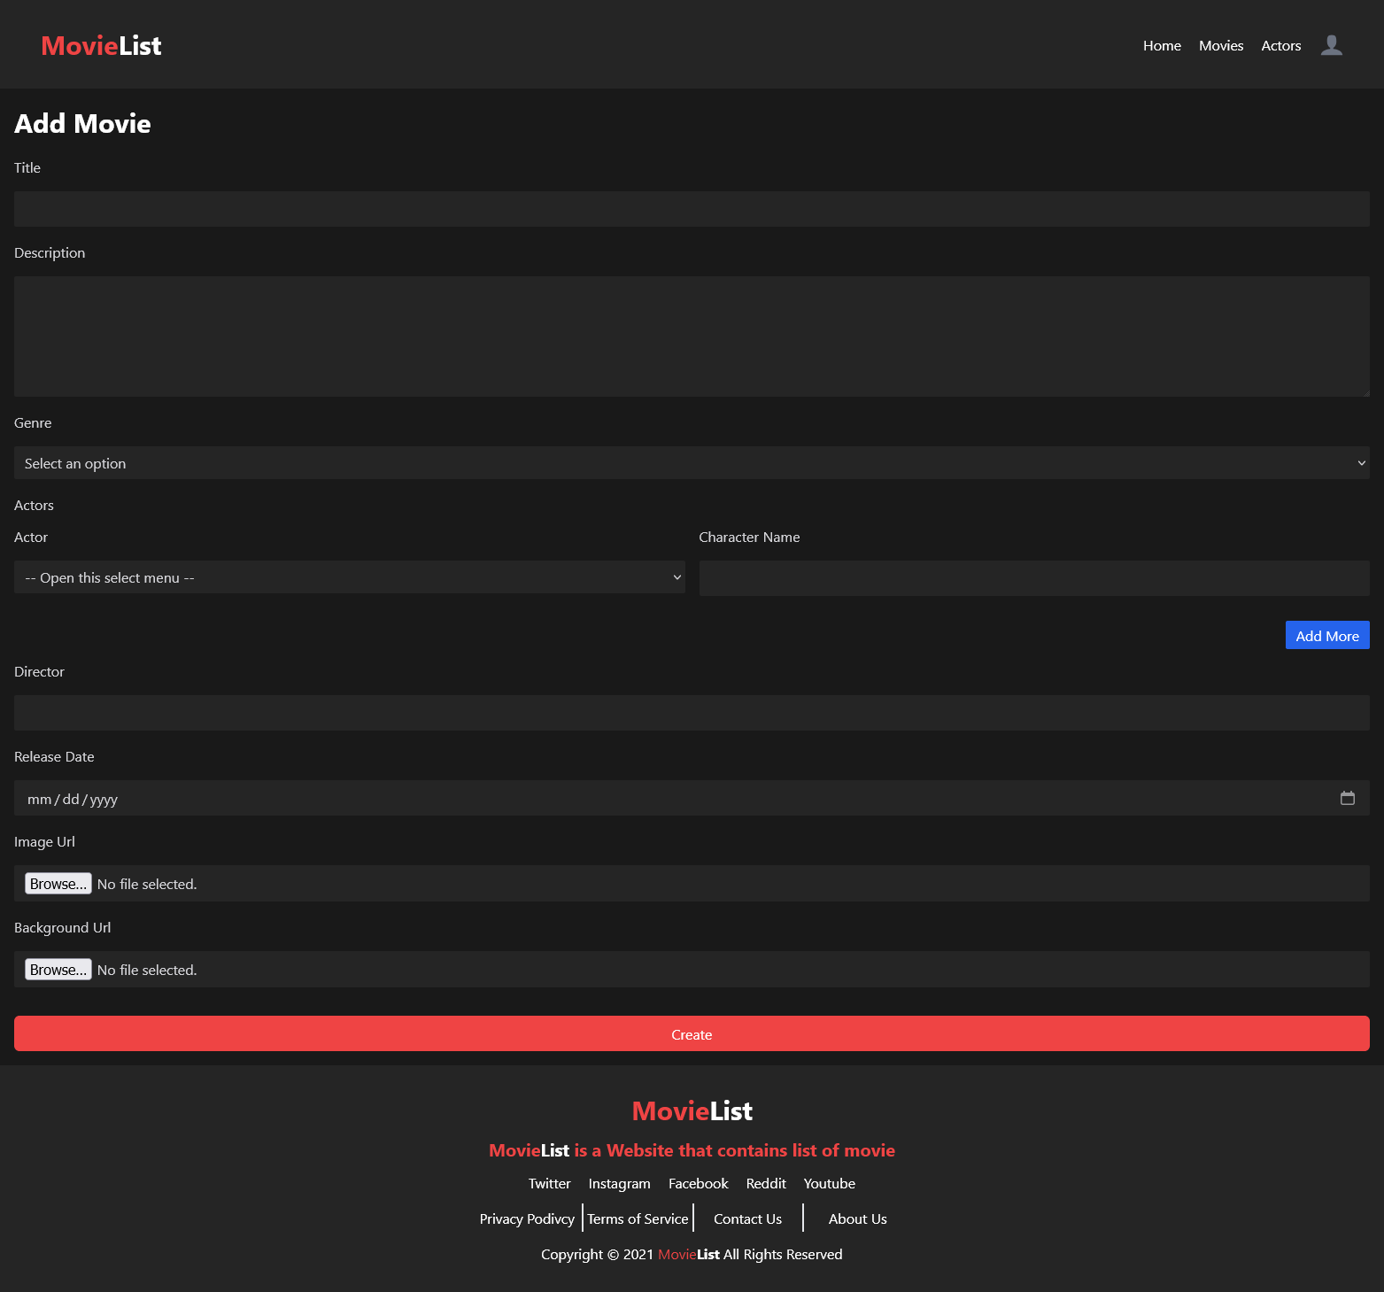

1. Edit Movie Page

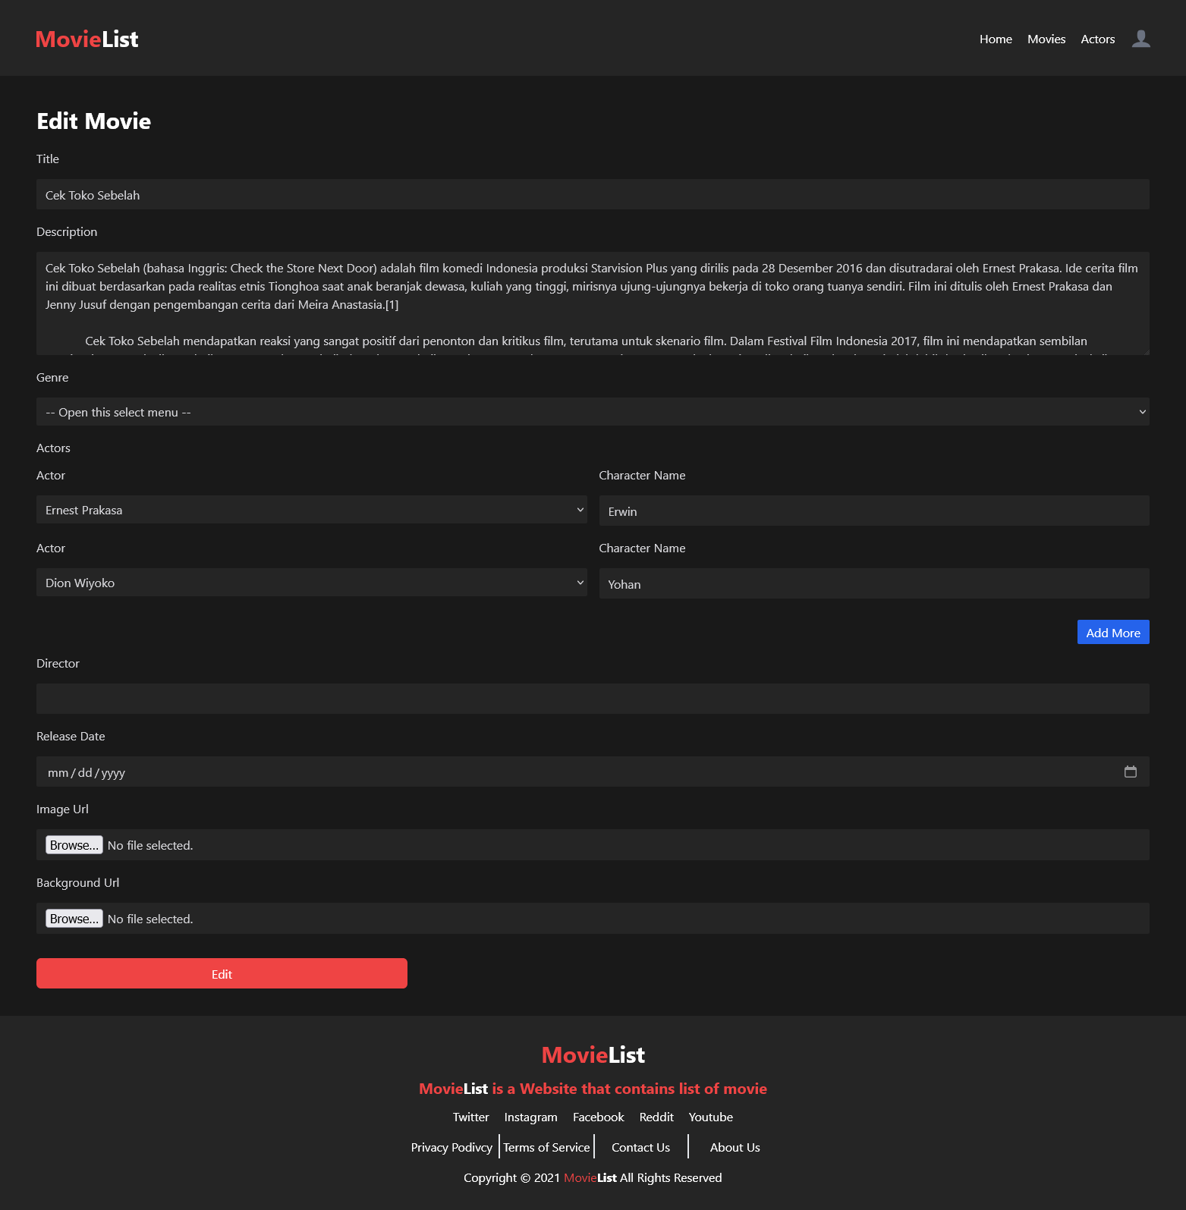

1. Movie Detail Page

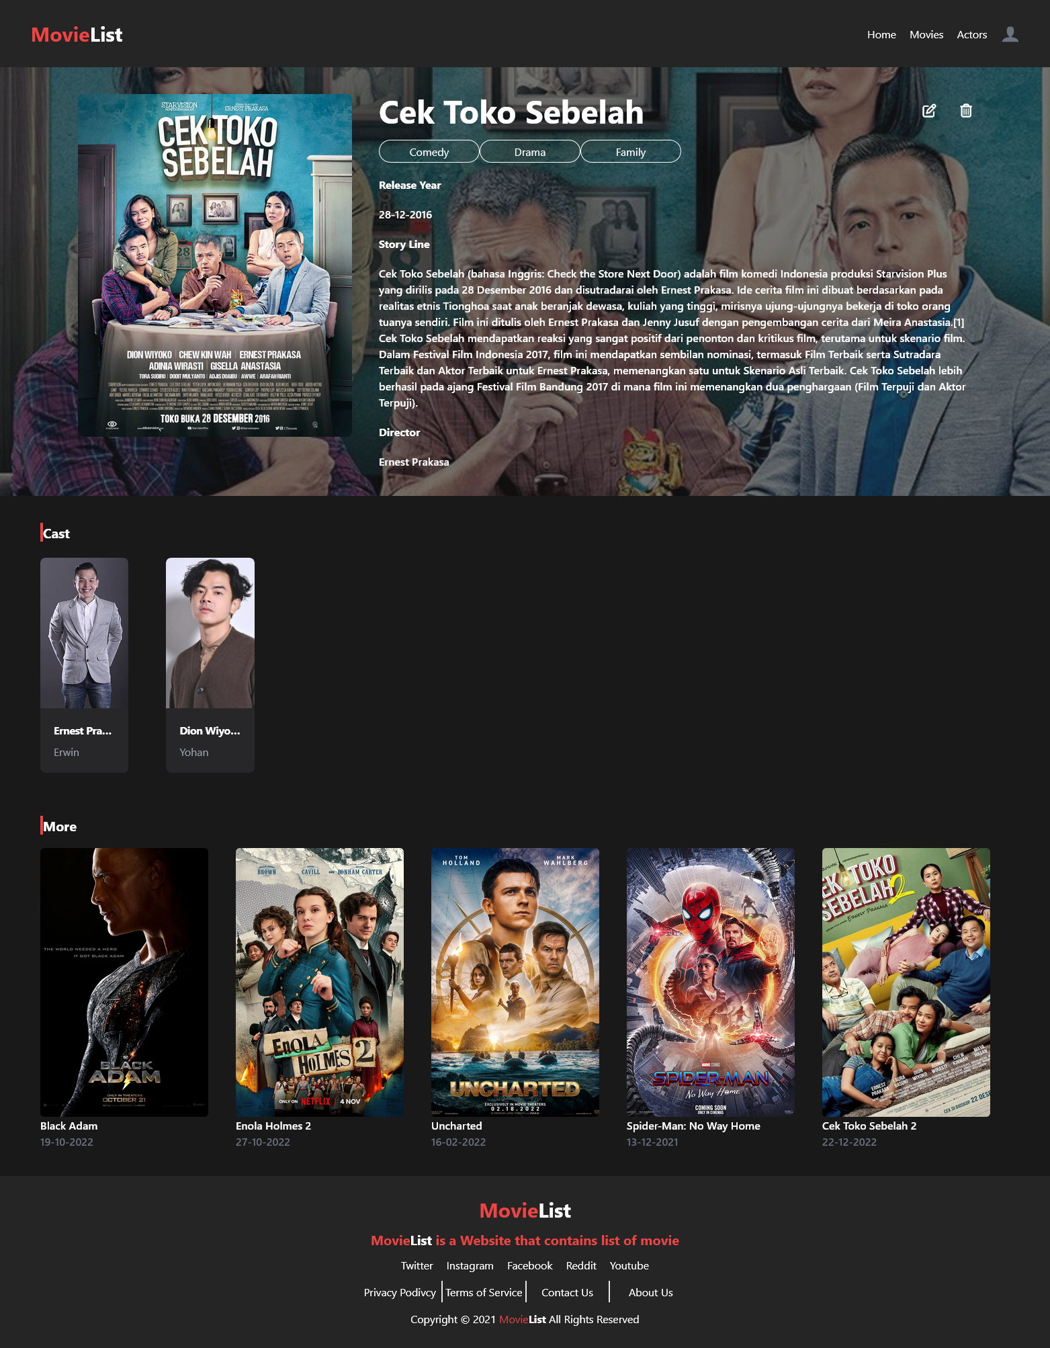

1. Actor Page
   1. Guest and User

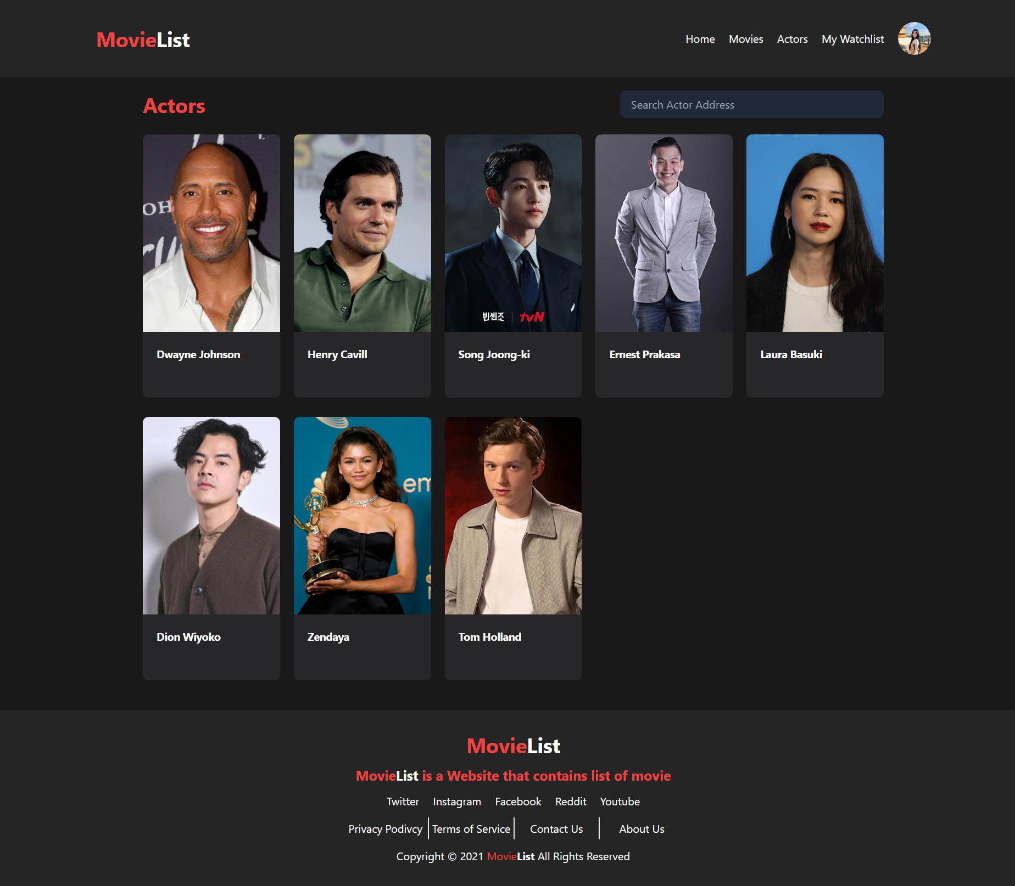

* 1. Admin

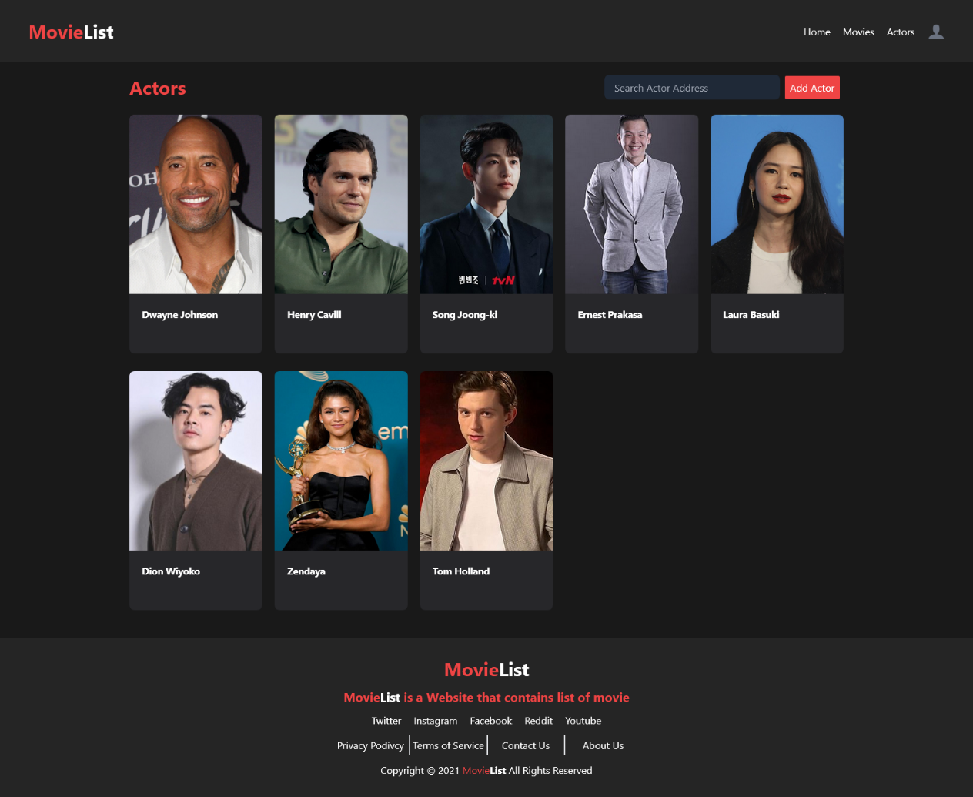

1. Actor Detail Page
   1. Guest and User

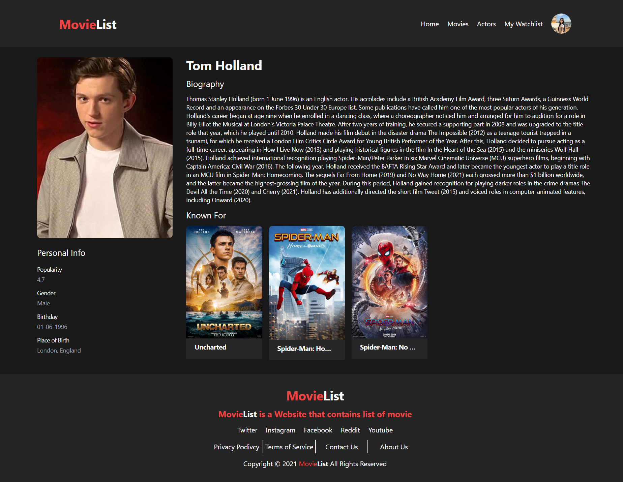

* 1. Admin

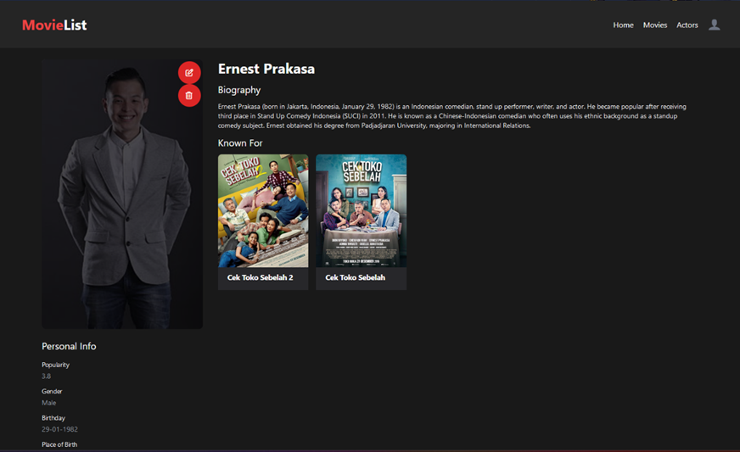

1. Create Actor Page

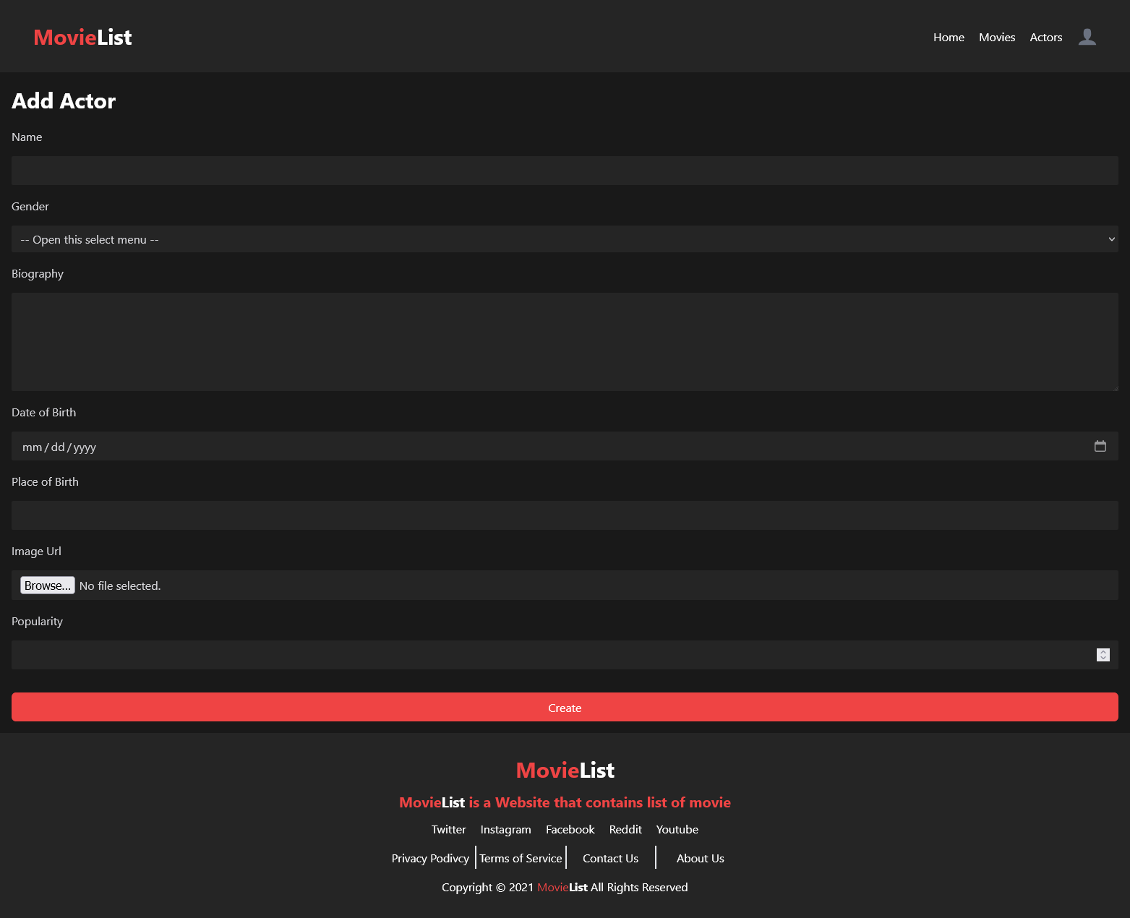

1. Edit Actor Page

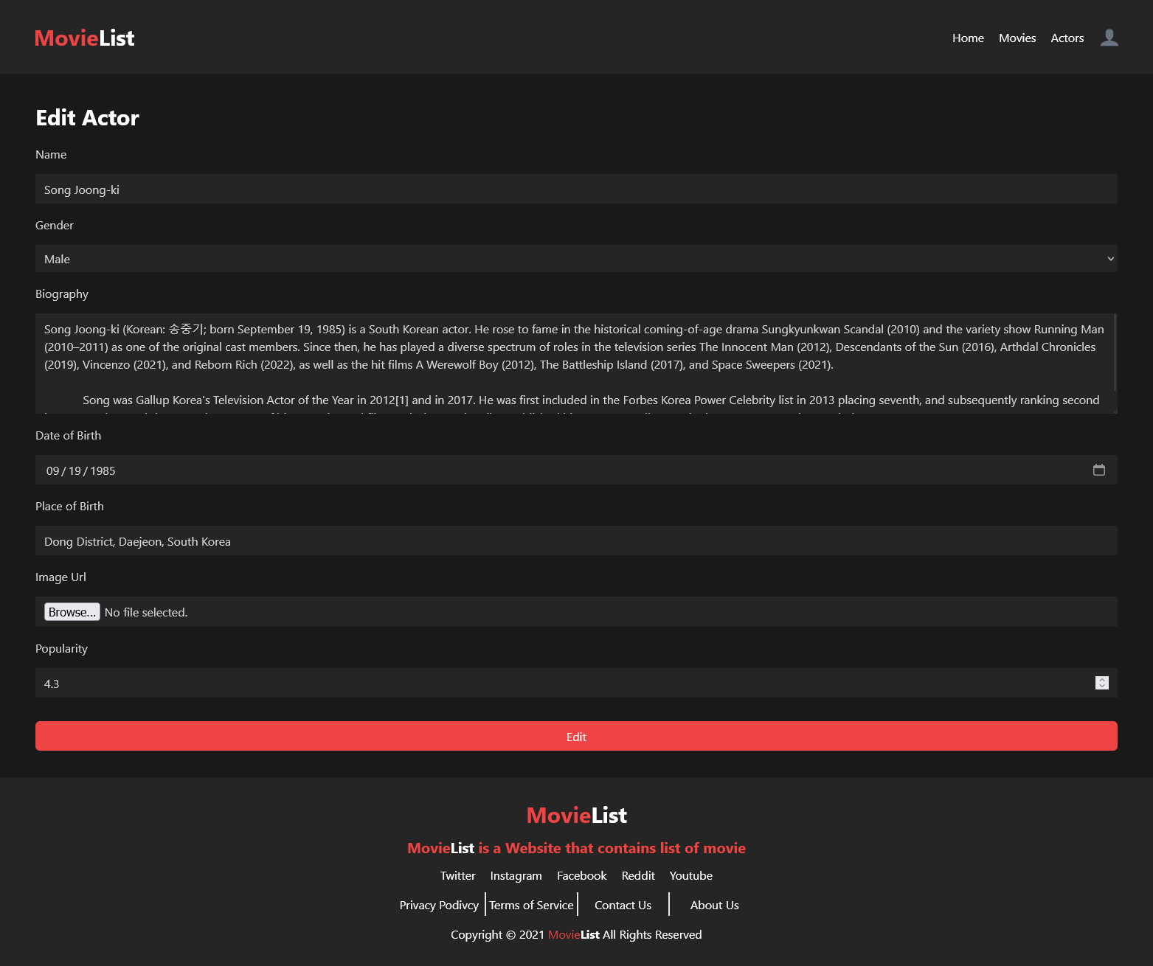

1. Profile Page

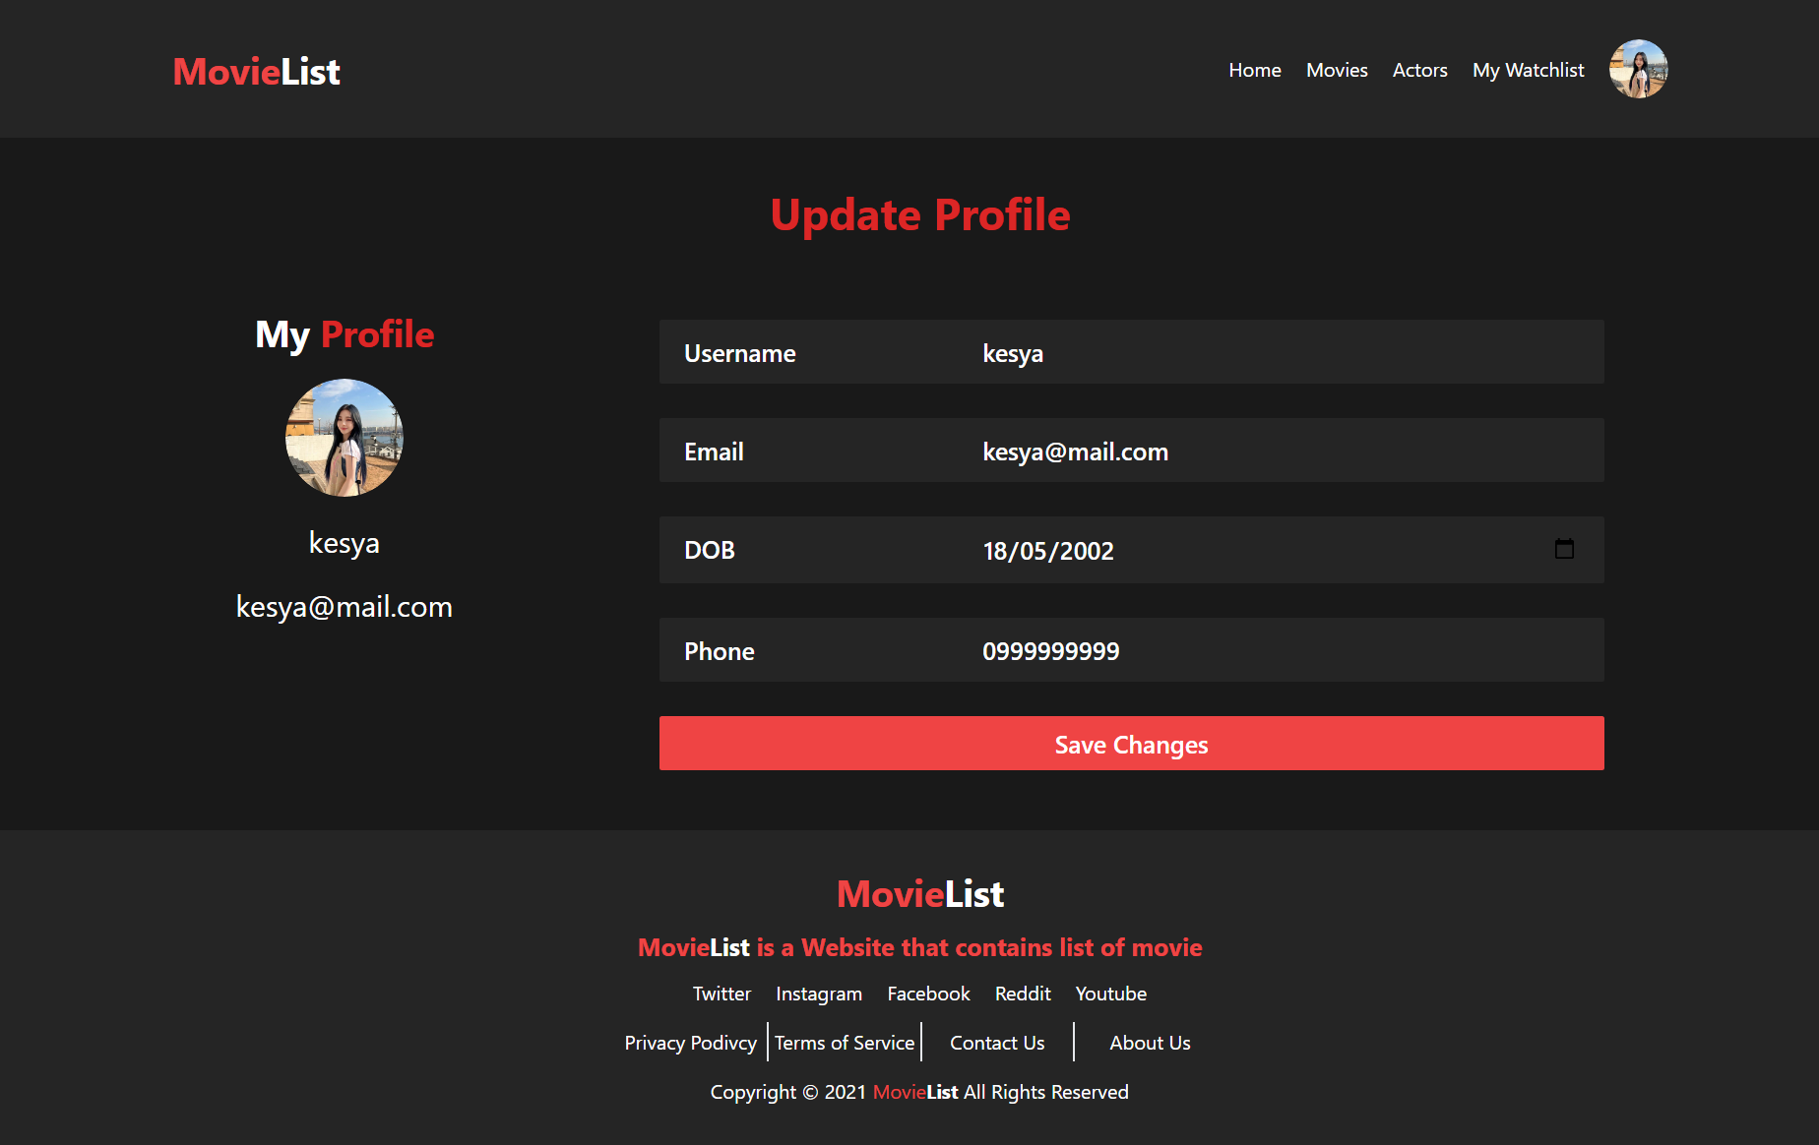

1. Watchlist Page

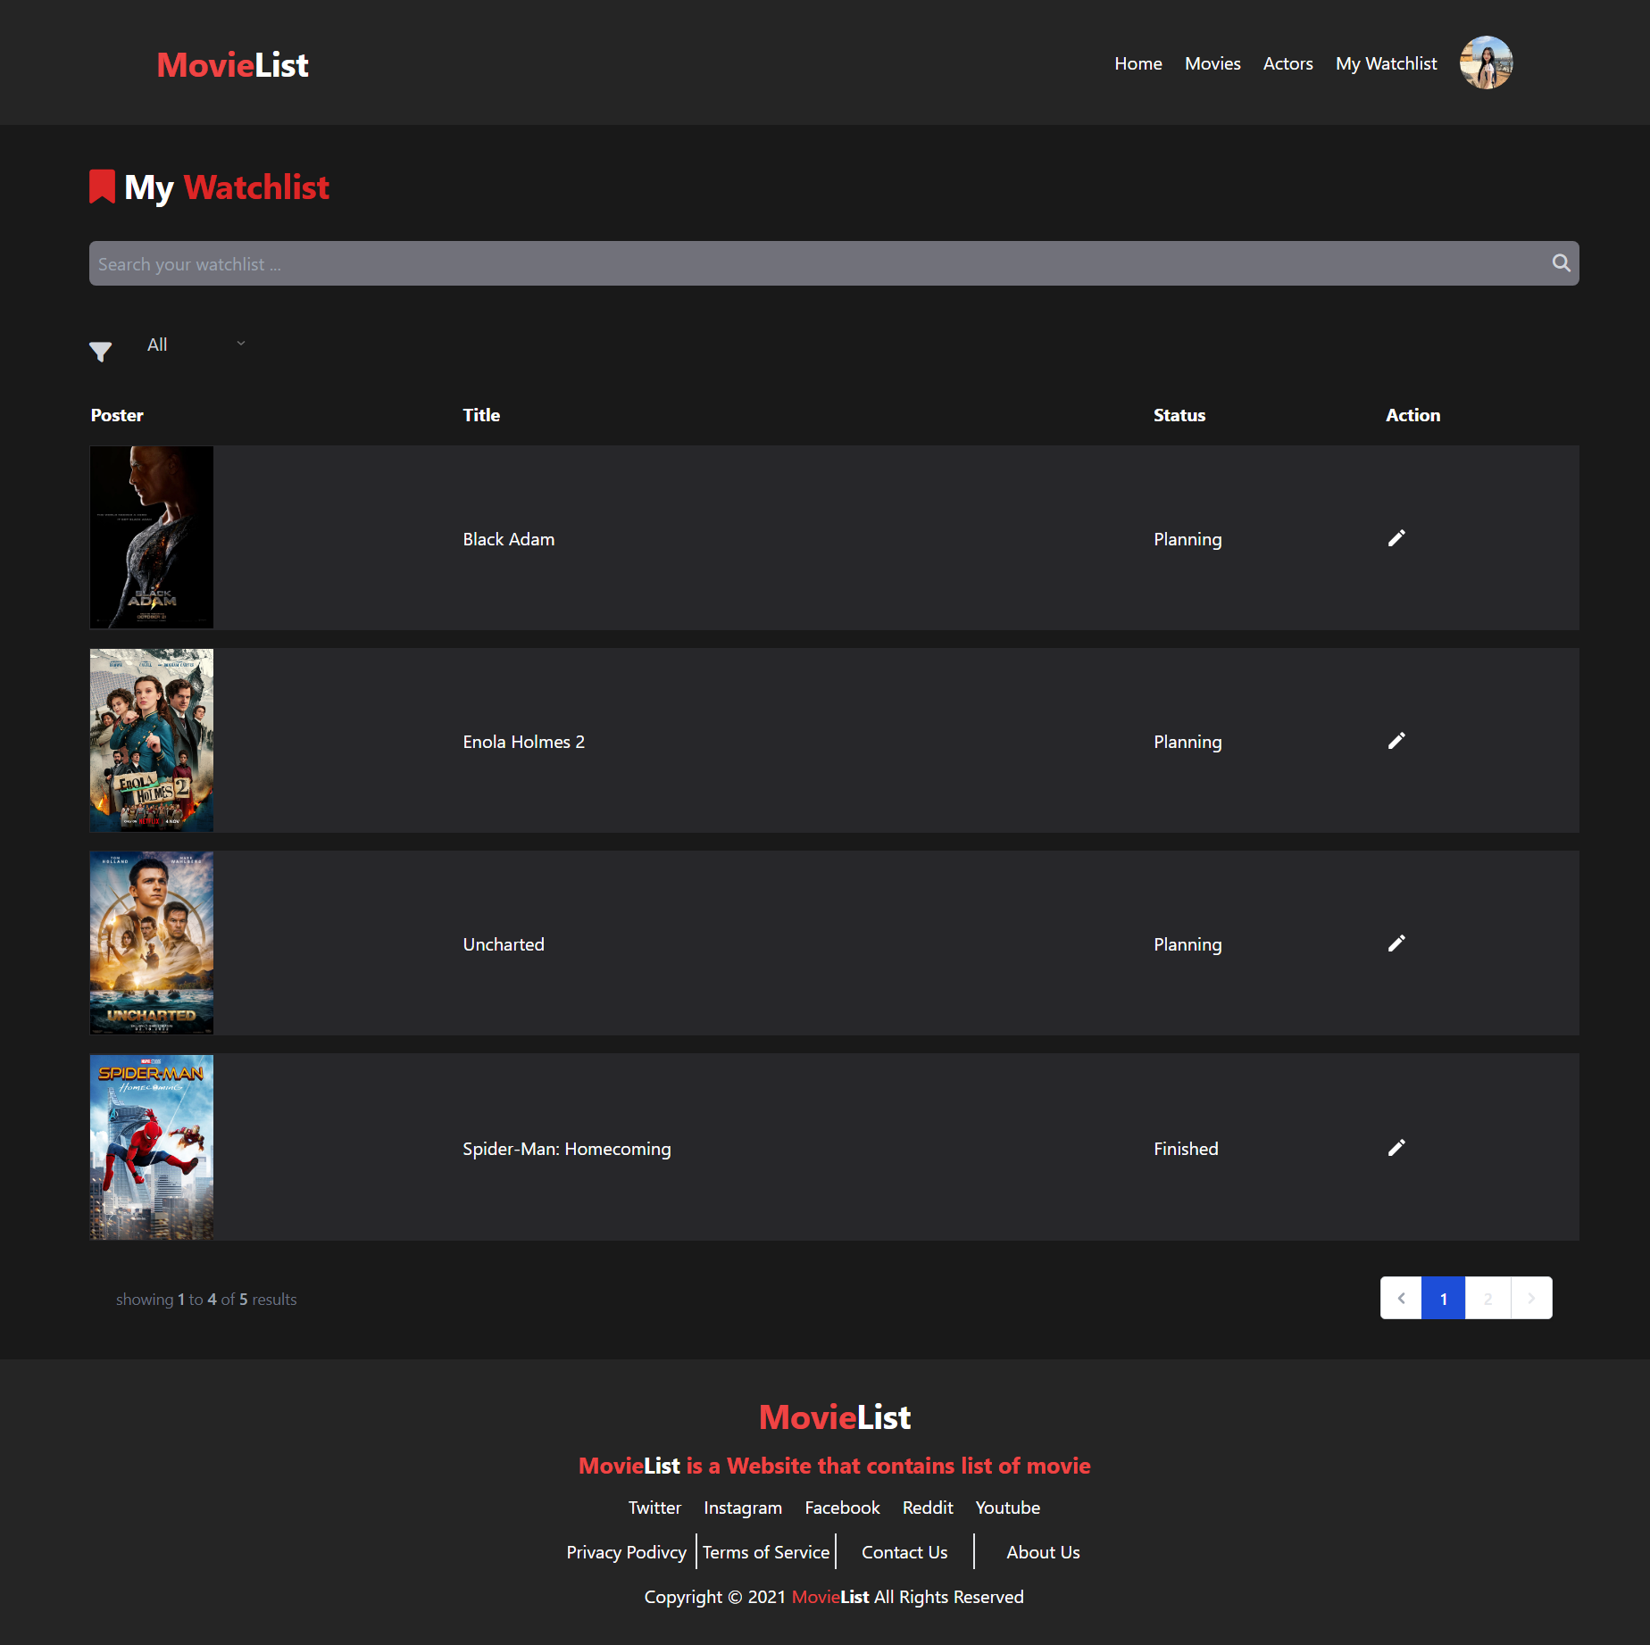

1. Navbar Dropdown
   1. Guest



* 1. User



* 1. Admin



* Reference
* https://assets.kompasiana.com/items/album/2022/11/04/mv5bmdi1nwm1zditndfhmi00ywrhltg1yzitntnhy2m2n2qzy2fkxkeyxkfqcgdeqxvymteymjm2ndc2-v1-63650ac24addee55751e0b22.jpg?t=o&v=770
* https://www.netflix-nederland.nl/wp-content/uploads/2022/10/Enola-Holmes-2-Netflix.jpg
* https://m.media-amazon.com/images/M/MV5BOGQ5YTM3YzctOTVmMC00OGIyLWFkZTYtMWYwOWZhMjA2MWMwXkEyXkFqcGdeQXVyMjUyMTE5MA@@._V1_.jpg
* https://img.okezone.com/content/2022/12/14/206/2727175/sinopsis-film-spider-man-homecoming-tom-holland-buktikan-layak-jadi-avengers-kQUkY5cxeL.jpg
* https://berauterkini.co.id/wp-content/uploads/2021/12/maxresdefault.jpg
* https://upload.wikimedia.org/wikipedia/id/2/20/Cek_Toko_Sebelah.jpg
* https://cdns.klimg.com/resized/1200x600/p/headline/ini-beda-cek-toko-sebelah-2-dengan-film-150ca0.jpg
* https://cdn0-production-images-kly.akamaized.net/Lerfg5MCvkPaF7ikRELGobntDCM=/640x853/smart/filters:quality(75):strip_icc():format(jpeg)/kly-media-production/medias/4246063/original/020284600_1669872803-MV5BNDMyYzNiMmMtYTA2OS00MWUwLWFkZDUtMDU1OTQ0ZDQ2NDU0XkEyXkFqcGdeQXVyMTEzMTI1Mjk3._V1_.jpg
* https://asset.kompas.com/crops/8A-aRrTXl8C6IRf-4_KvxkUJXxc=/0x503:912x1111/750x500/data/photo/2020/09/24/5f6c8dadcf5ff.jpg
* https://m.media-amazon.com/images/M/MV5BMWEwNjhkYzYtNjgzYy00YTY2LThjYWYtYzViMGJkZTI4Y2MyXkEyXkFqcGdeQXVyNTM0OTY1OQ@@._V1_.jpg
* https://www1.realgbedu.com/wp-content/uploads/2022/02/Uncharted.jpg
* https://statics.indozone.news/local/62a03f2cb5b8b.jpg
* https://chatterboxfilm.com/wp-content/uploads/2022/06/16546545168992604020237937246684.png
* https://o-cdn-cas.sirclocdn.com/parenting/images/Karina_4.width-1000.jpg
* https://upload.wikimedia.org/wikipedia/commons/1/1f/Dwayne_Johnson_2014_%28cropped%29.jpg
* https://cdn0-production-images-kly.akamaized.net/7gprLJZKQm1OLOpj-67pXxbZ0jU=/640x640/smart/filters:quality(75):strip_icc():format(jpeg)/kly-media-production/medias/3446551/original/010975200_1620025786-180775179_315551359977402_3739374589533792753_n.jpg
* https://upload.wikimedia.org/wikipedia/commons/thumb/7/7a/Laura_Basuki_at_Berlinale_2022_Picture_2.jpg/1200px-Laura_Basuki_at_Berlinale_2022_Picture_2.jpg
* https://upload.wikimedia.org/wikipedia/commons/thumb/2/21/Merem_Melek_Mgmt-_Ernest_P.JPG/1200px-Merem_Melek_Mgmt-_Ernest_P.JPG
* https://upload.wikimedia.org/wikipedia/commons/3/30/Henry_Cavill_%2848417913146%29_%28cropped%29.jpg
* https://upload.wikimedia.org/wikipedia/commons/thumb/f/fd/Tom_Holland_MTV_2018_%2802%29.jpg/220px-Tom_Holland_MTV_2018_%2802%29.jpg
* https://cdn0-production-images-kly.akamaized.net/CcQD83ox3_UtCmYdZdNvukgZNbU=/1200x900/smart/filters:quality(75):strip_icc():format(jpeg)/kly-media-production/medias/4155958/original/090491400_1663047255-Zendaya-Emmy-Awards-2022-AP-7.jpg
* https://thumb.zigi.id/frontend/thumbnail/2022/07/29/zigi-62e3ac21cd13d-dion-wiyoko_910_512.jpg
* Group Member
* 2440021426 – Kesya Amanda Wijaya
* 2440007485 – Frisco Lieyanto